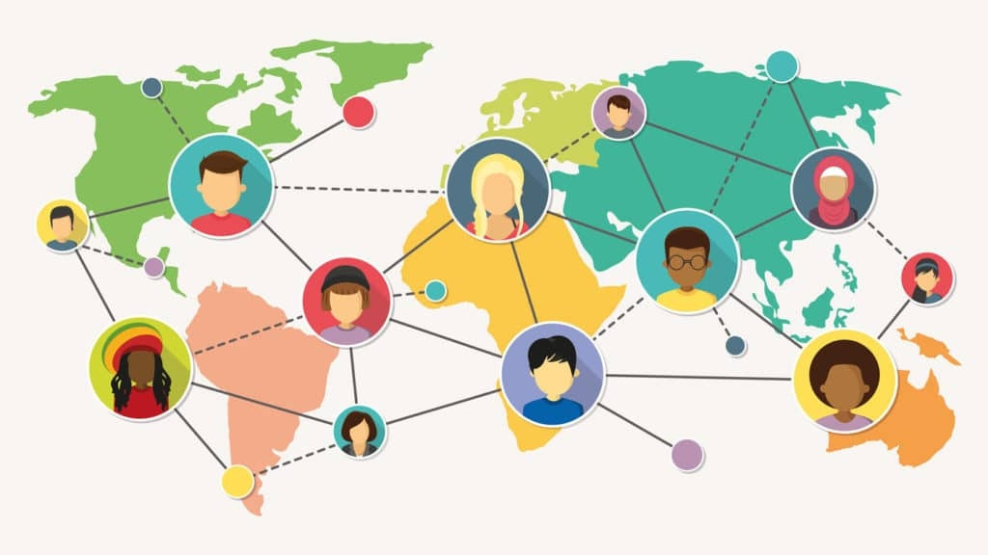
Spring Health Case Study

Taking Mental Healthcare Solution Global

Client

A leading comprehensive global mental health solution for employers. It started its journey back in 2016 and has been growing since then.

The client is a leading comprehensive global mental health solution provider for employers. It began its journey in 2016, with a valuation of $2 billion in September 2021, and has been steadily growing since then.

The company wanted to reach more lives and in order to do so, they planned to extend their care outside the US. This comes with its own set of challenges in localizing the application, which includes introducing new languages and updating the existing content.

The main problems our client was struggling with -

- Scalability – In order to efficiently scale to more countries and languages
- Introducing support for new countries
- Introducing support for new languages

What We Did

- Created a framework to enable global offerings in the web application
  - Country specific language content
  - Streamline workflow integrating a third-party translation service
- Extended international offering to 41 more countries in 22 more languages
- Upgraded major project dependencies to access internationalization packages

Outcomes

- 41+ countries
- 22+ languages
- 3 months for going live
- Easy quick process to add more countries and languages

Created a framework into enable global offerings in the web application -

To Bridge the gap in its global offering our team established a framework (develop and deployed) withing a small period of 3 month which helped our client to save money and time. While developing the global framework the first requirement was to make the product more user friendly and for that we focused on -

- Country specific language content

Locales-

In order to connect with more lives and for better customer experience we added Primary and Secondary languages for every country added in the production environment. But the problem was length of words and sentences as they wary in different locales also some locale uses a script that is read and written in right-to-left direction.

So while expanding to more countries and supporting more locales we have taken several factors in consideration such as:

- Direction of the flow of information
- Bidirectionality of icons
- Animation of UI elements
- Exceptions such as phone numbers, dates and email addresses

There were so many ways to accomplish this, but after careful consideration, using logical CSS properties appeared to be the best option for our use case.

This meant that the layout should be considered in terms of text, such as the start and end rather than the left and right. While this modification enables RTL layout, we had to ensure that it didn't break with the current LTR layout in any way.

- Third party translation service integration -

So when the translation comes into the picture the biggest question was to translate the content stored on both frontend and backend codebases. We also wanted to do it in a quick and pocket-friendly manner.

Lets see how we solve the problem -

Frontend -

A simple local frontend application will have all the static content in its codebase itself and ours was no different. Once the configuration for internationalization were in place, the next step was to actually move all the static string literals to a specific file format. To speed up the work

- We chose a standard file format - JSON to store all our translations and thus when moved, the static content got replaced with references to the content in these JSON files. This makes it easier to load the translations on switching locales.
- The content was static and the translations need to be generated and stored before going live so we come up with a solution in form of Crowdin, a third-party localization service.
- The service syncs up with the repository on GitHub and reads only the locales folder that it needs to translate.
- Crowdin was setup in such a way that it creates a Pull Request with translations pointing to the relevant feature branch. The author of the feature branch can review and merge the translations in and now any newly added features with always have all the static content in all the configured locales.

Backend -

On the backend we were using an API built on rails that serves all of the data used by our web app, and as any other API most of our data is stored in a database.This posed a very interesting challenge as we had to translate the database content in a manner where our third party vendor i.e. crowdin can also integrate to automate the translation.

This is when we introduced a database + rails-i18n approach for serving translated content and

- Identified all the attributes in individual models that need translations.
- Extract the English data for these attributes into rails-i18n recognizable YAML file structure, this was done using some rake tasks.
- Integration of Crowdin to provide translations for the automated locales.
- Implemented custom attribute readers in the models, that depending on the current language utilized either the database or rails-i18n to fetch the attribute value. We relied on the database for serving English content and rails-i18n and YAML files for serving translated content.

This custom approach minimized response times for the majority of our users and introducing YAML files for locale data allowed us to utilize Crowdin for providing automated translations.

- Translating Emails

Just like many other applications, we also utilize email for communication with the user, and to connect with global users, we had to make sure that our emails were translated too.

The major bottleneck here was that our mails were handled by rails views which needs a lots of dev intervention. We needed a tool that someone from a non-tech background could easily use. That is when we introduced Iterable -

- It’s a service that provided an easy-to-use WYSIWYG drag and drop editor to create mail templates.
- It had embedded ruby like data plugin features using its robust API, along with these it also came with detailed metrics and telemetry service, campaigns and workflows.
- We just had to setup the mail templates on Iterable and setup the API with our backend application to send in required data, and boom! You had globalized emails!

Conclusion -
A keen study of our clients requirements and careful selection of suitable solutions helped us to achieve the following for our client and us -
- Live global framework within 3 months
- Saved time and money
- Presence in 41+ countries with 22+ languages
- Improved client satisfaction and Global business
- Trust and long-term association with client

